**Assignment 6**

**Objective** – Power BI Desktop, Cloud Service and End to End Workflow

**Use Case** – DAX Measures

**Source** – LifeScience

**Analytics** – DAX Groupings

**Report/Dashboard** – LifeScience

**Loading the data**

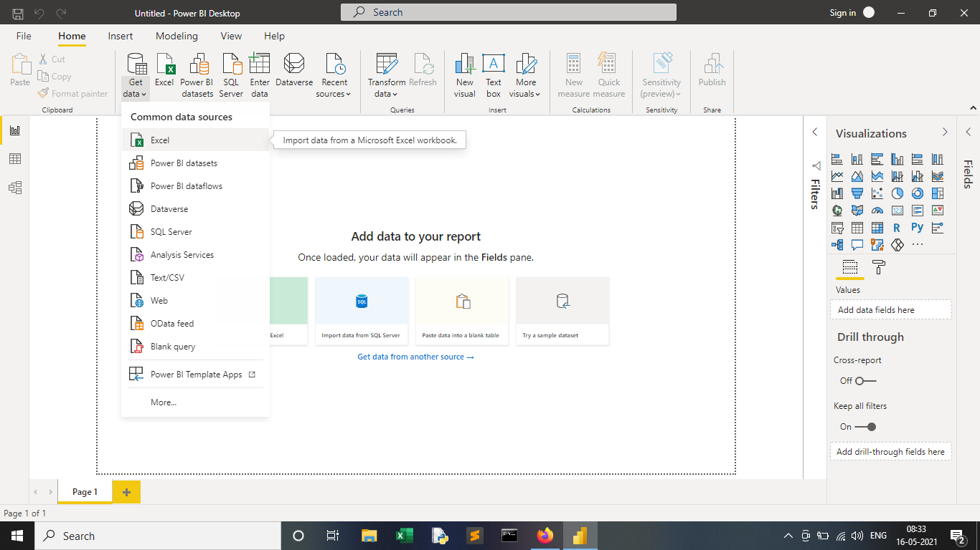

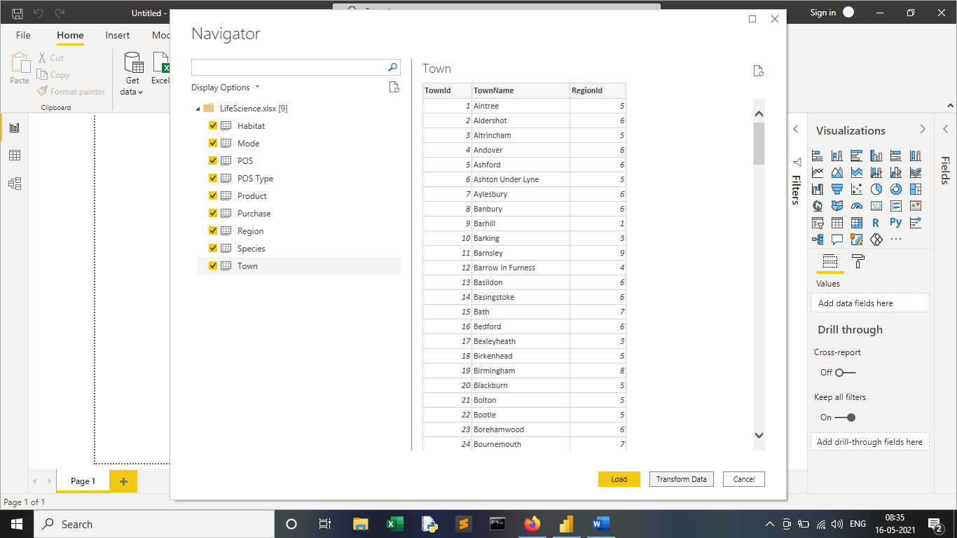

**Create the following segment in terms of Purchase**

**- Affordable (if< 10)**

**- Expensive (if >10)**

First, we need to find purchase cost by creating a new column in Purchase Table. Go to Data view & click on New Column for Purchase Table. Name the new column as Purchase cost . Write the Dax expression for it.

**Purchase cost** = Purchase [Price] * Purchase [Quantity]

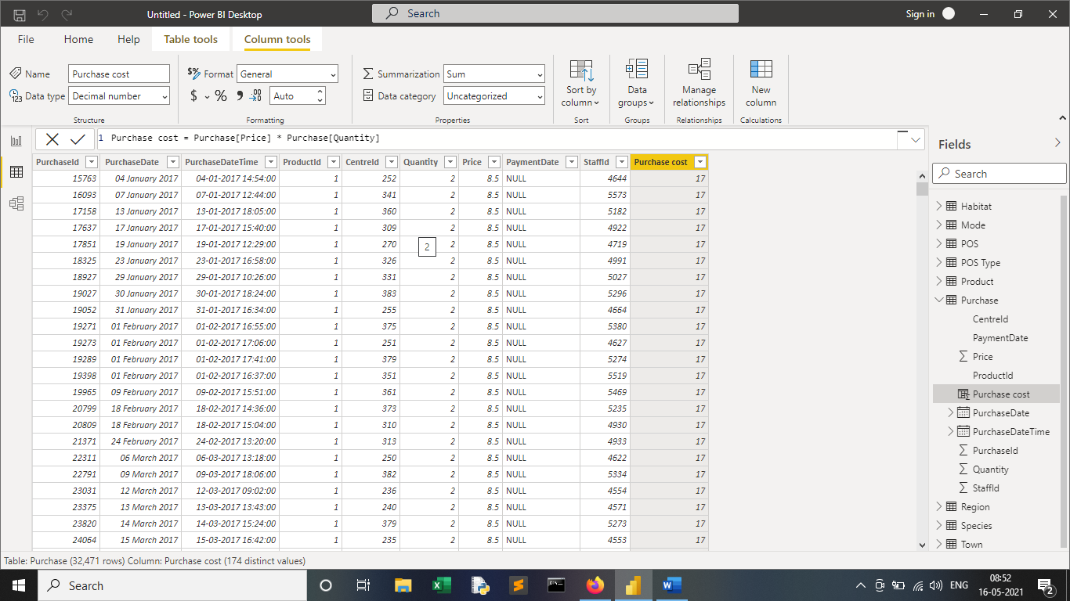

**Purchase type**= IF (Purchase[Purchase cost]<10,"Affordable","Expensive")

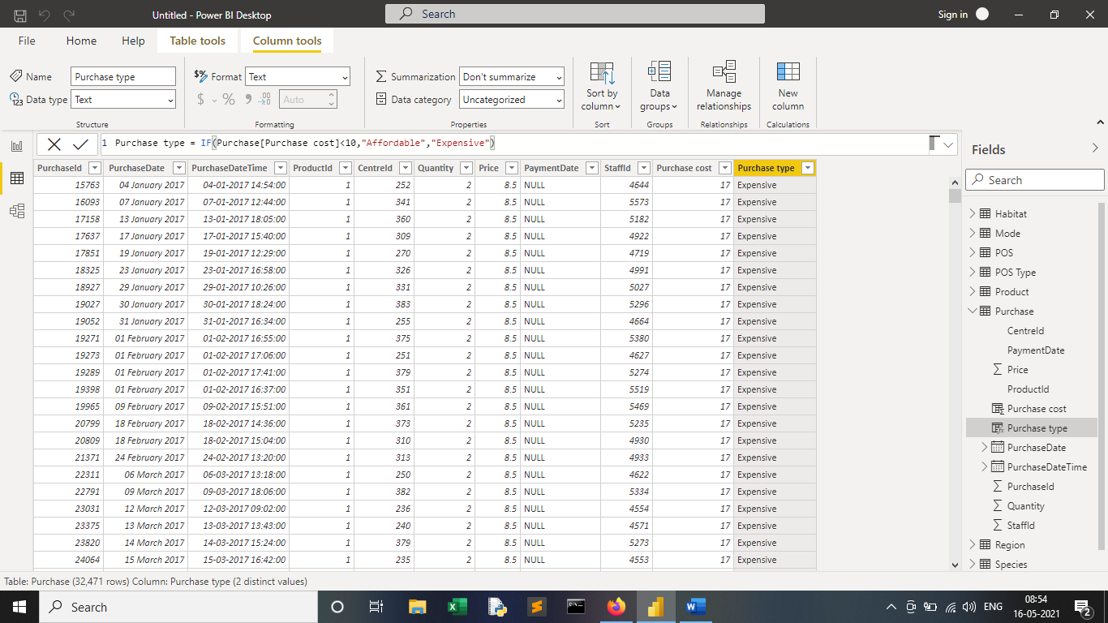

**Need to know how many animals do not belong to Air, Water & land**

In order to how many animals do not belong to air, land & water, create three measures in Product table using the formulas are as follows:

Not Air = COUNTROWS(filter('Product',RELATED(Mode[EnvironmentId]) in {1,3}))

Not land = COUNTROWS(filter('Product',RELATED(Mode[EnvironmentId]) in {2,3}))

Not Air = COUNTROWS(filter('Product',RELATED(Mode[EnvironmentId]) in {1,2}))

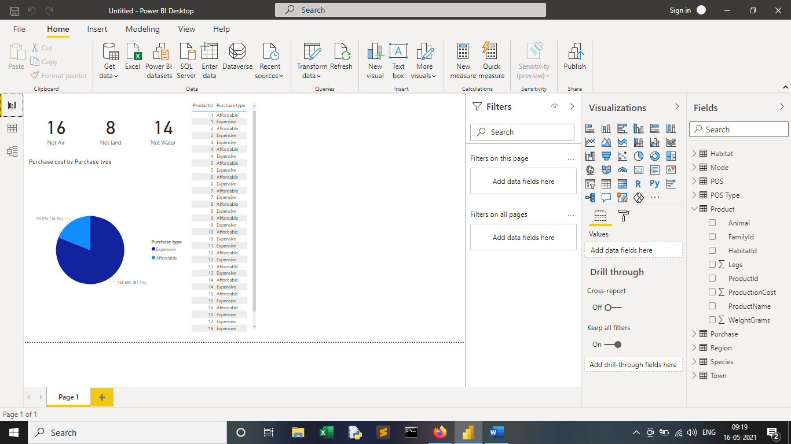

**Create a segment on the basis of Species by the referring Animals and create a column in the required table.**

**We can Achieve through the Syntax (RELATED)**

To use **RELATED**, we always need to ensure that relationship exists between the current table and the table with related information.

If a relationship does not exist, First we need to create a relationship.

**Go to Data View--> Select Product Table--> Click on New Column--> Write Query**

**Species =RELATED(Species[FamilyName])**

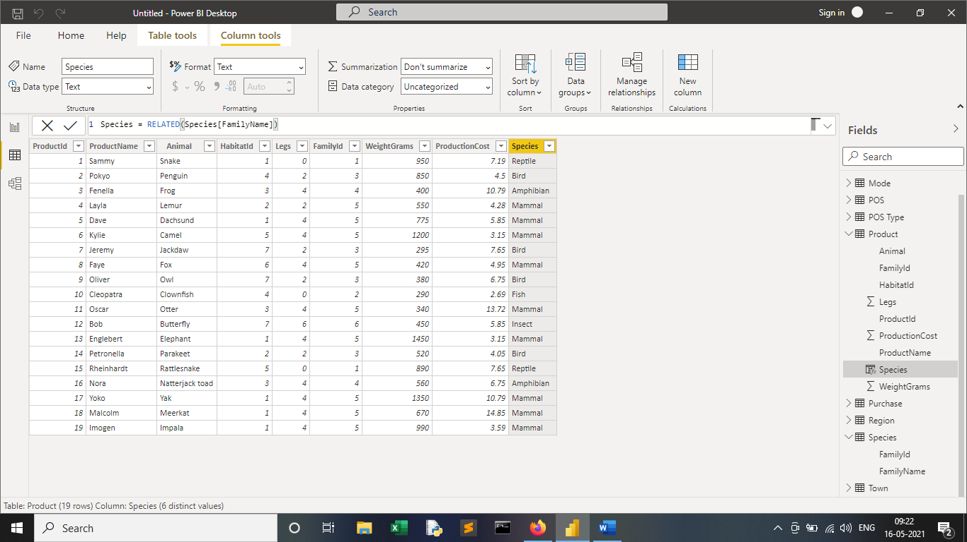

**Need to segment the towns on the basis of region**

Required solution can be achieved again using DAX Syntax **(RELATED)**

**Go to Data View--> Select Town Table--> Click on New Column--> Write Query**

**Region = RELATED(Region[RegionName])**

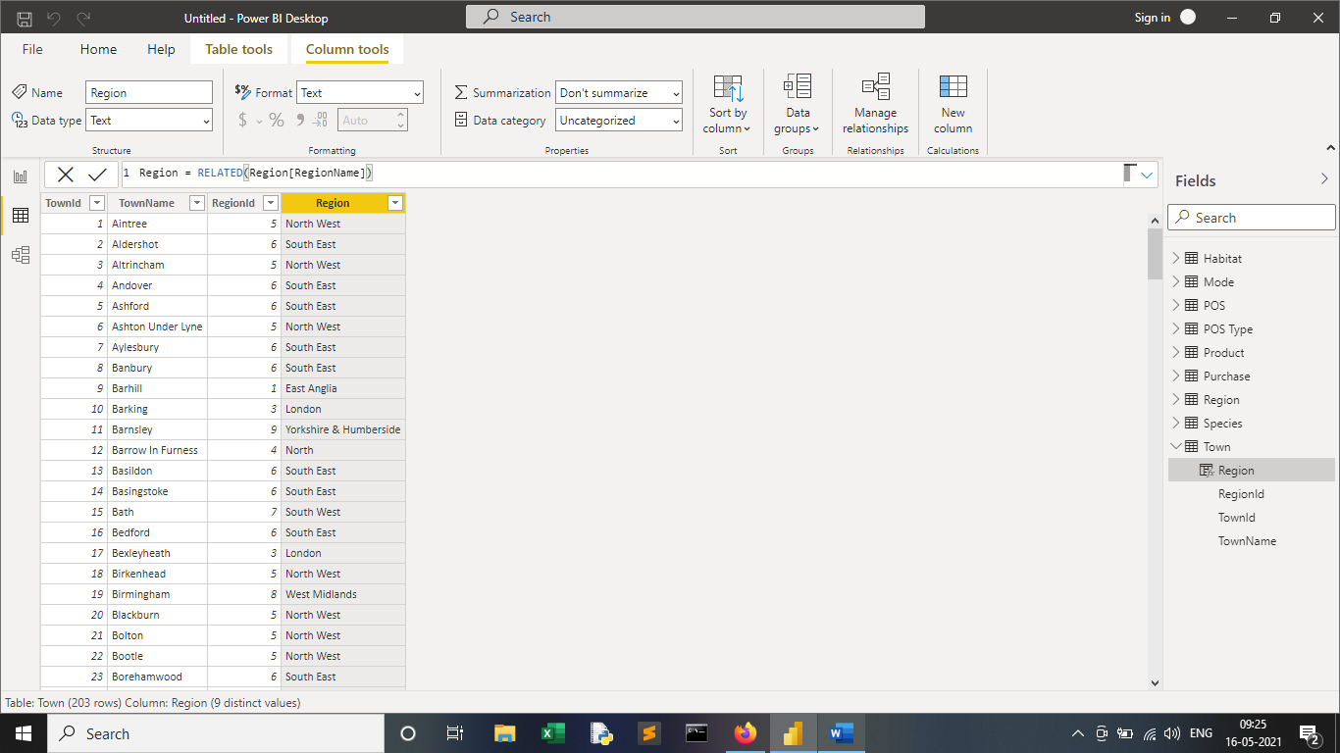

**Final Dashboard**

